**RESOURCE TABLE**

***CREATE TABLE SYNTAX :***

CREATE TABLE TABLE_NAME(<column-list>

[<constraint-list>]

);

CREATE TABLE ResourceTbl (

ResNo VARCHAR2(8) CONSTRAINT RTBLResNoNOTNULL not null,

ResName VARCHAR2(15) CONSTRAINT RTBLResNameNOTNULL not null,

Rate FLOAT(2) CONSTRAINT RTBLRateNOTNULL not null,

CONSTRAINT PK1_ResourceTbl1 PRIMARY KEY(ResNo),

CONSTRAINT CheckRate CHECK(Rate>0)

);

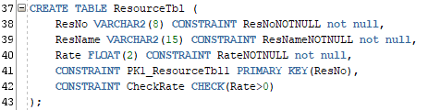

***INSERT STATEMENT :***

INSERT INTO TABLE_NAME(col_1,col_2,…col_n) VALUES (exp_1,exp_2,……exp_n);

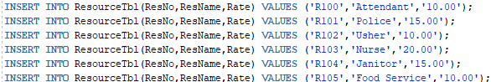

***SELECT STATEMENT :***

SELECT * FROM TABLE_NAME;



***OUTPUT :***

